Microsoft Word

Contents
New Document 3
Save 3
Keyboard Shortcuts 3
Headers and Footers 4
Spacing 4
Columns 4
Fonts 5
Styling 5
Tables 6
Images 6
Page Breaks 6
Orientation 7
Table of Contents 7

New Document
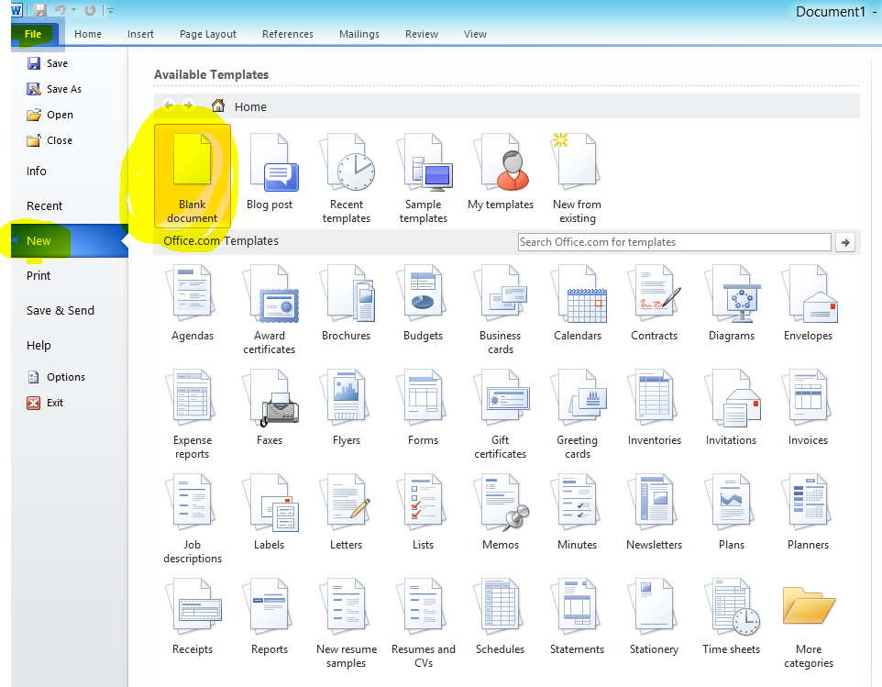

Save
Save often
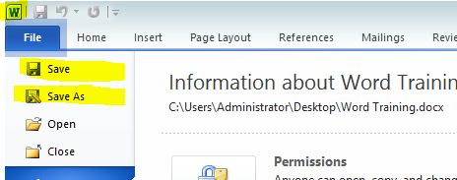

Keyboard Shortcuts

Save – CTRL + S
Copy – CTRL + C
Paste – CTRL + V
Undo – CTRL + Z
Redo – CTRL + Y
Find – CTRL + F
Find and Replace – CTRL + H

Headers and Footers
And Page Numbers
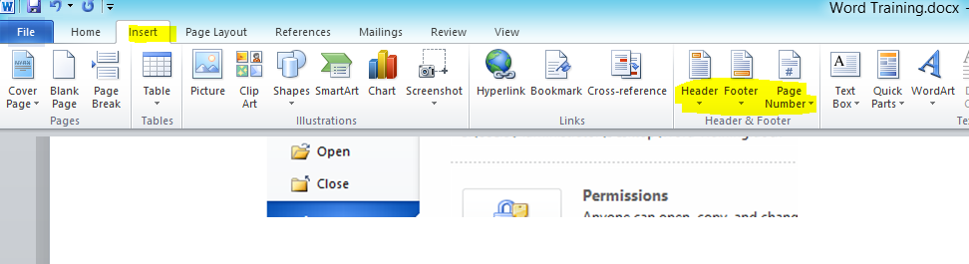

Spacing
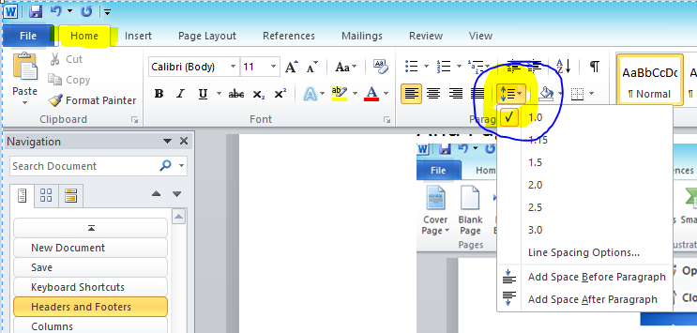

Columns
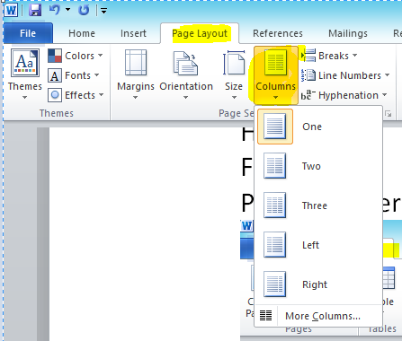

Fonts
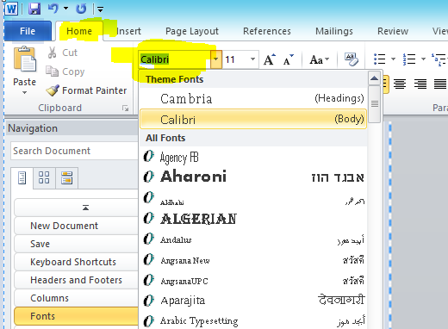

Styling
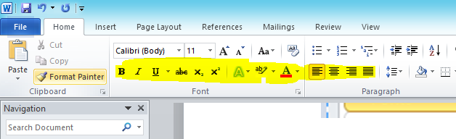

Tables
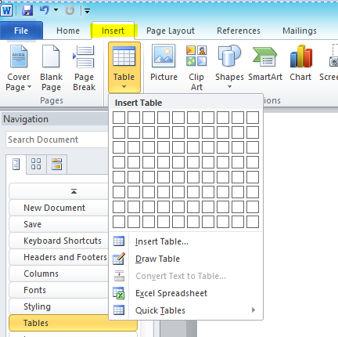

Images
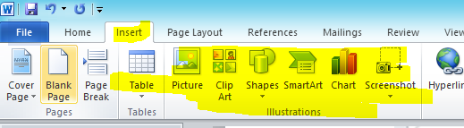

Page Breaks
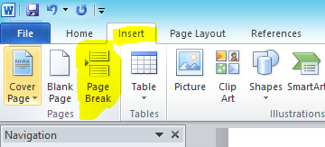

Orientation
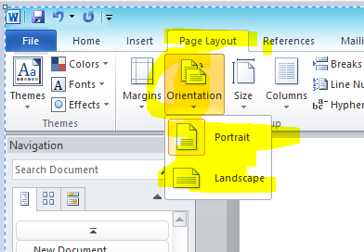

Table of Contents
